# 



Week – 1

Learning About Docker

Documented by-Darshit Jung KC

# Summary

In this project, Maven is employed as the build tool for managing and automating the build process of a Java application. The application's dependencies, configurations, and build lifecycle are specified in the project's Maven configuration file (pom.xml).

The application utilizes a MySQL database, and to streamline the deployment and management of the database, Docker is employed. The MySQL database is containerized, meaning it is encapsulated within a Docker container, allowing for consistent and reproducible deployments across different environments. Docker Compose is used to define and orchestrate the multi-container application stack, providing a simple way to manage the entire application environment, including both the Java application and the MySQL database.

Here's a breakdown of the key components and their roles in the project:

Maven:

Maven is utilized as the build automation tool to manage the project's build lifecycle, dependencies, and project structure.

The pom.xml file contains project configurations, dependencies, and build plugins.

Java Application:

The Java application source code is structured according to Maven conventions.

Maven is used to compile, test, and package the application into executable artifacts (e.g., JAR or WAR files).

MySQL Database:

The MySQL database is containerized using Docker.

Docker provides a lightweight, isolated environment for the MySQL database, ensuring consistent behavior across different environments.

Docker Compose:

Docker Compose is employed to define and manage the multi-container application stack.

The docker-compose.yml file specifies the services (containers) needed for the application, including the MySQL database and any other required services.

Deployment and Scaling:

The Docker Compose file simplifies the deployment process, allowing for easy scaling or replication of the application stack if needed.

Docker containers facilitate portability and consistency, enabling developers to run the application stack on different environments with minimal configuration.

By combining Maven for build automation and Docker with Docker Compose for containerized deployment, the project achieves a streamlined and reproducible development, testing, and deployment process. Developers can easily manage dependencies, build the application, and deploy the entire stack, including the MySQL database, using standardized and version-controlled configurations

# Docker

Docker is a set of platforms as a service (PaaS) product that use OS-level virtualization to deliver software in packages called containers.

Docker Setup

Creating Profile & Setting up repository

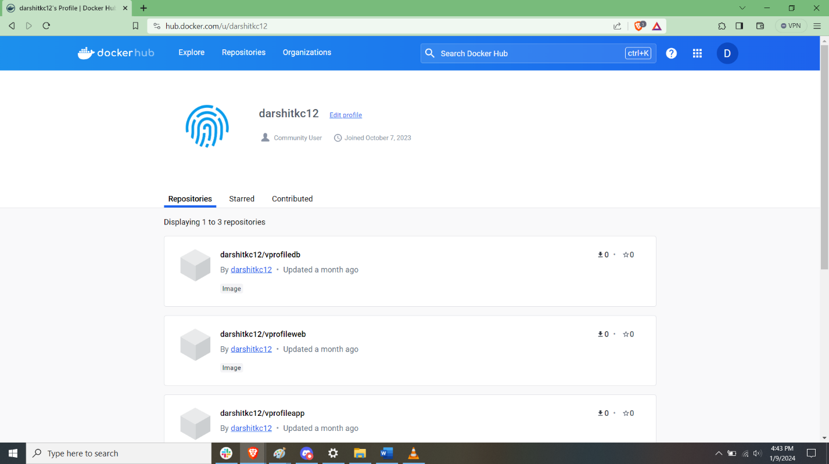

Creating directory to work on project

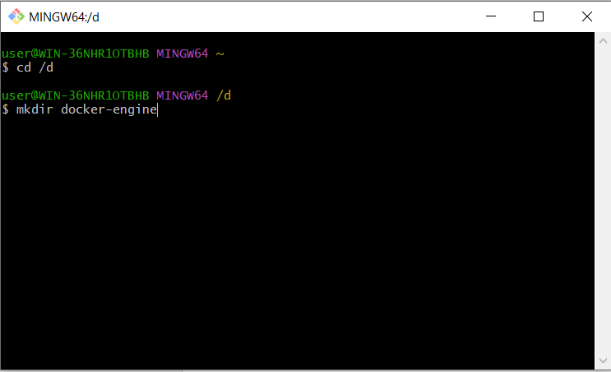

Initializing vagrant file for running VM

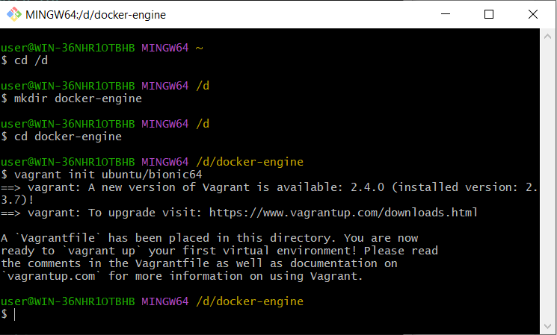

Edit VM configuration file



Allowing VM to be access through web

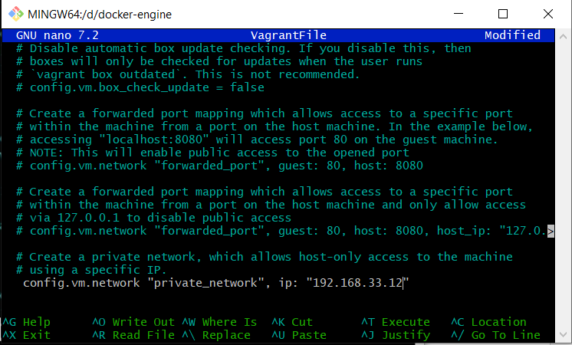

Running VM

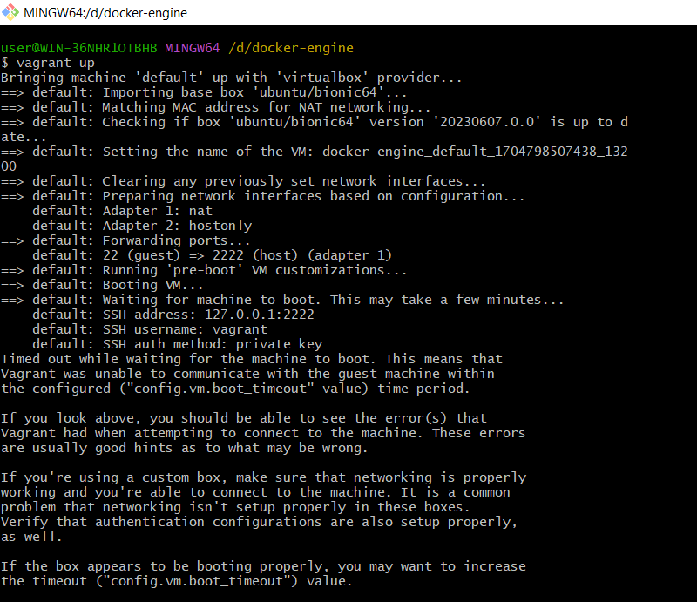

Accessing VM through shell

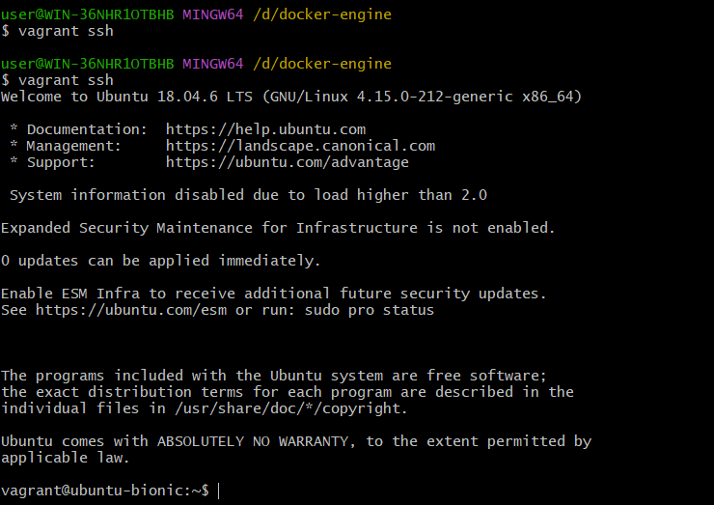

Giving super user do permission

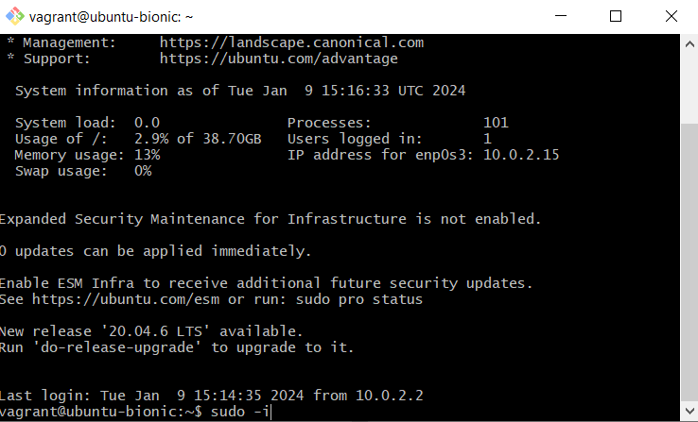

Installing Docker using git repository

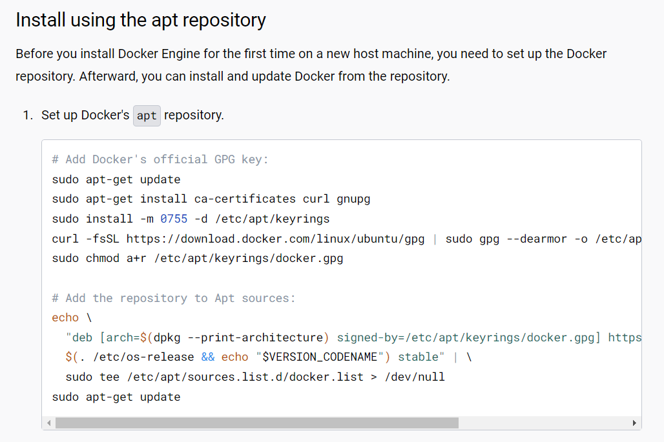

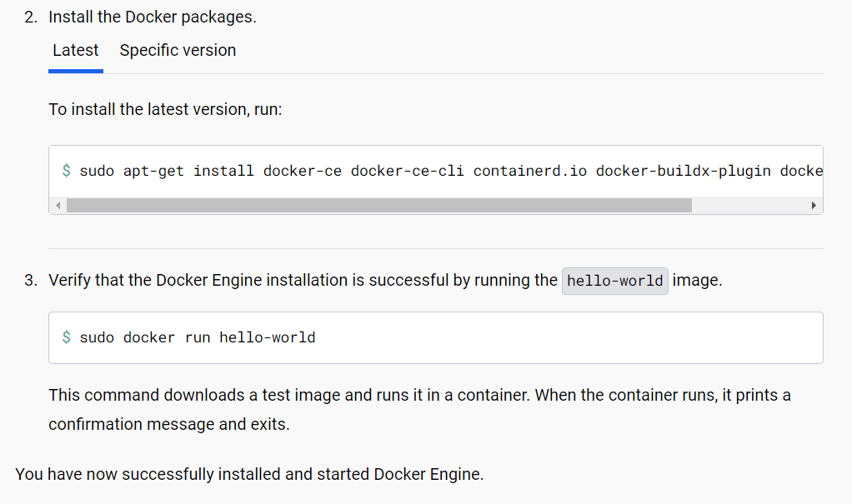

Logging in in docker through shell

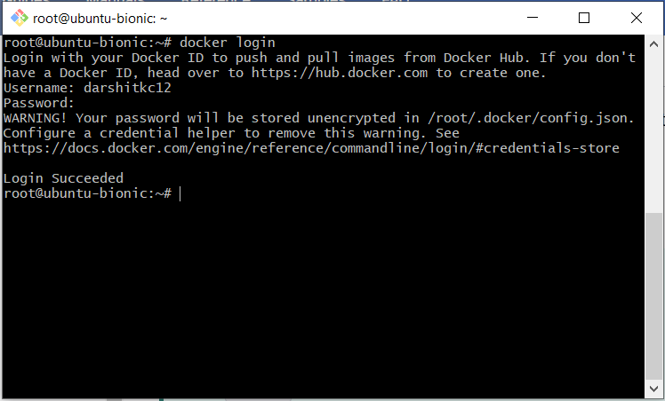

Checking docker status

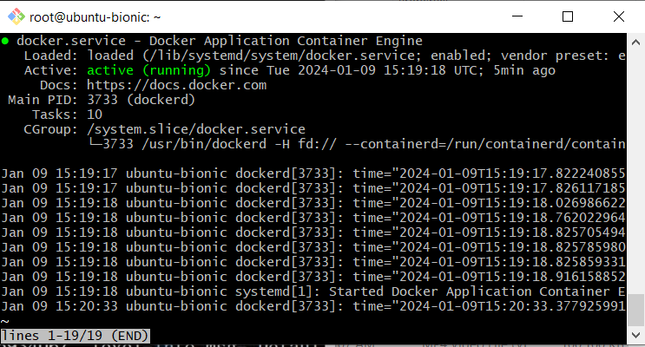

Building project through maven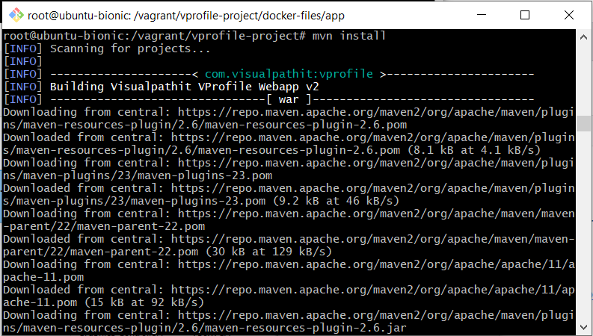

Copying artifact to another directory

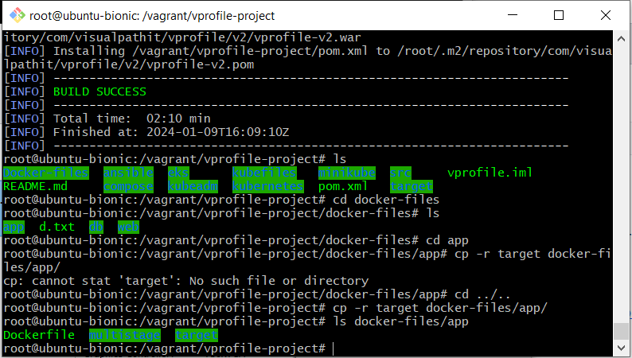

Application is being built as docker container

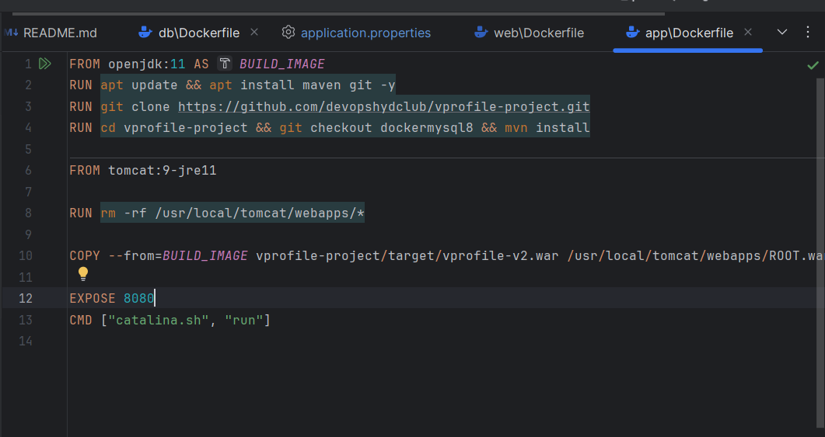

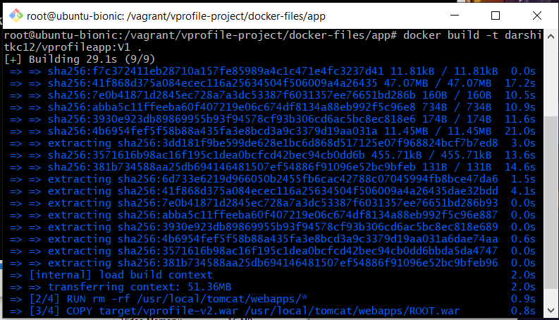

Checking docker images

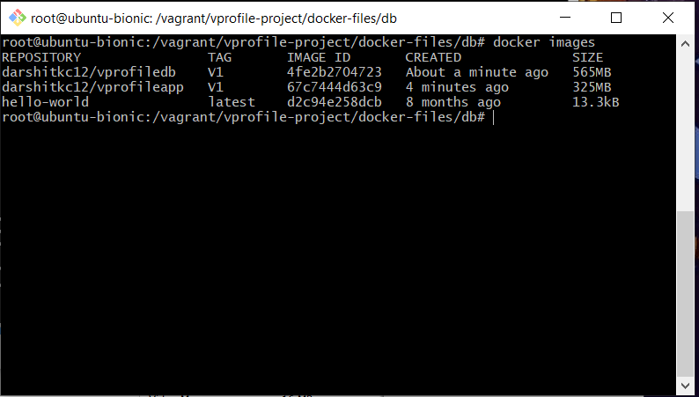

Building database as docker container

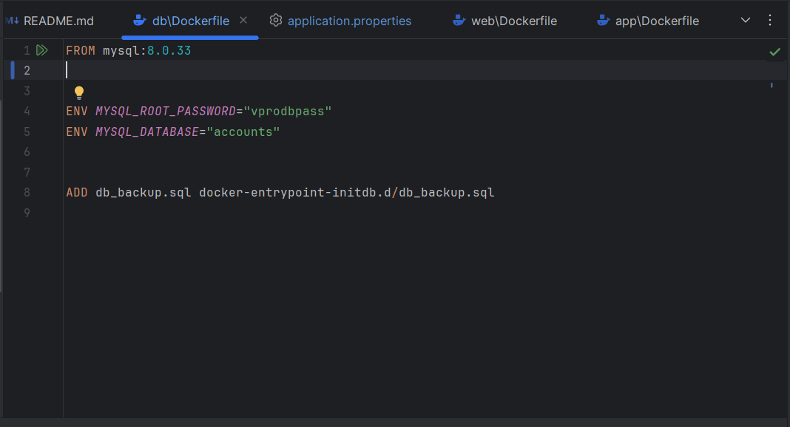

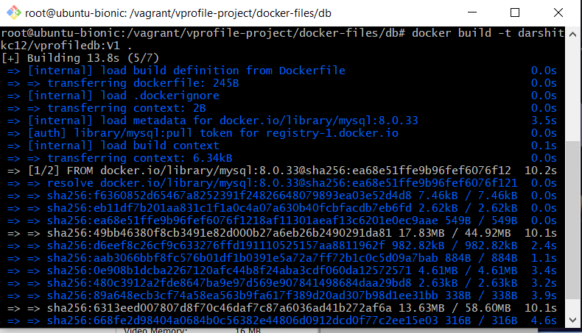



Building web images as docker container

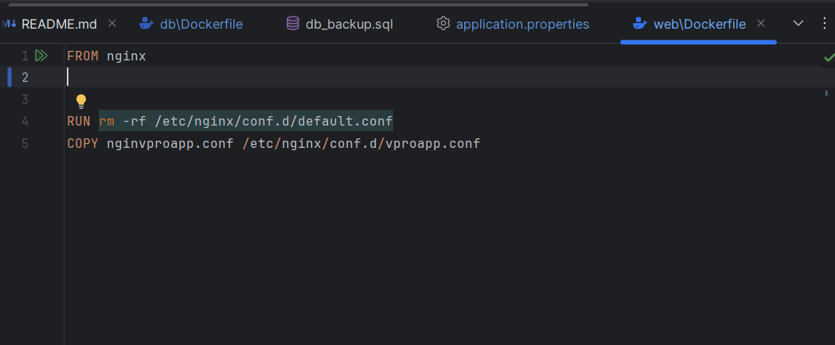

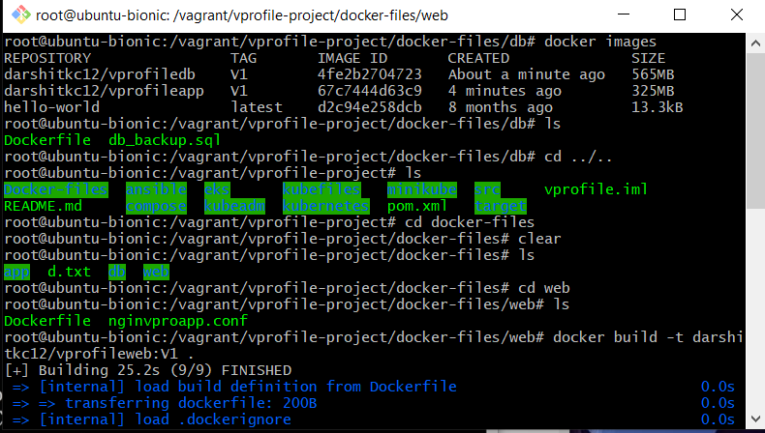Pulling rabbitmq from docker repository

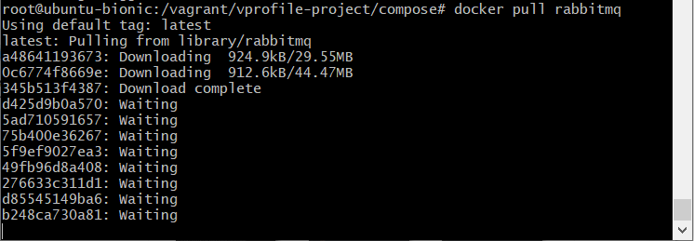

Pulling tomcat from docker repository

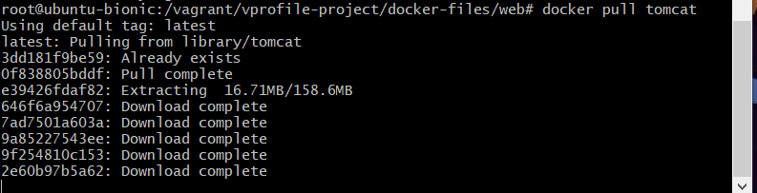

Installing Docker Compose

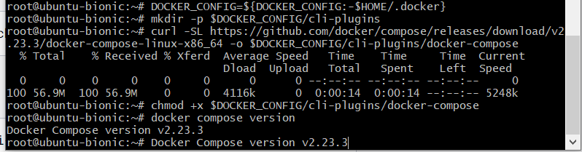

Running docker compose

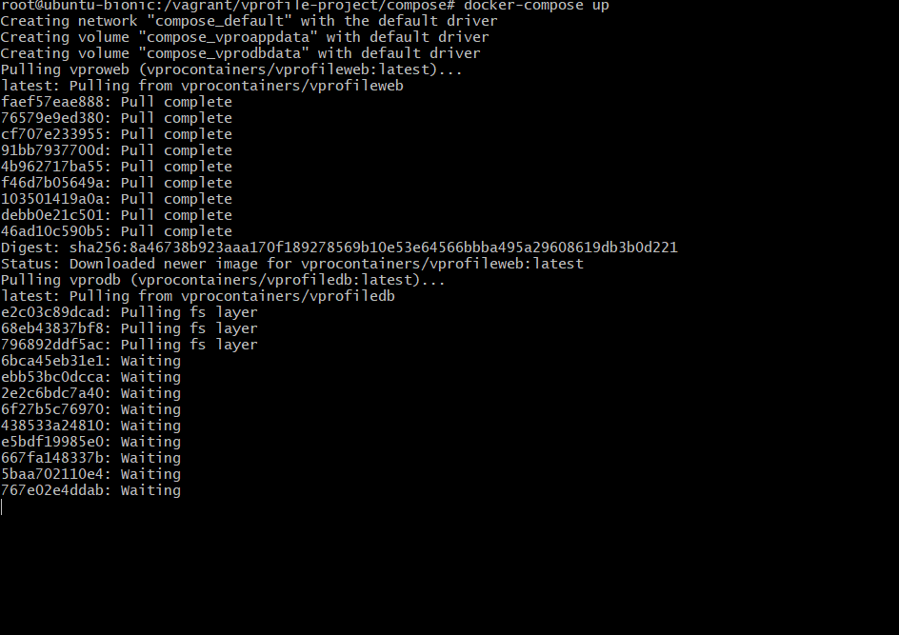

Verifying application through browser

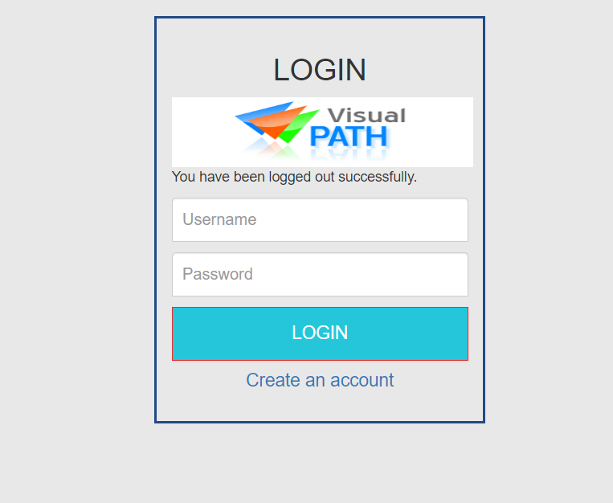

Checking if application is working properly

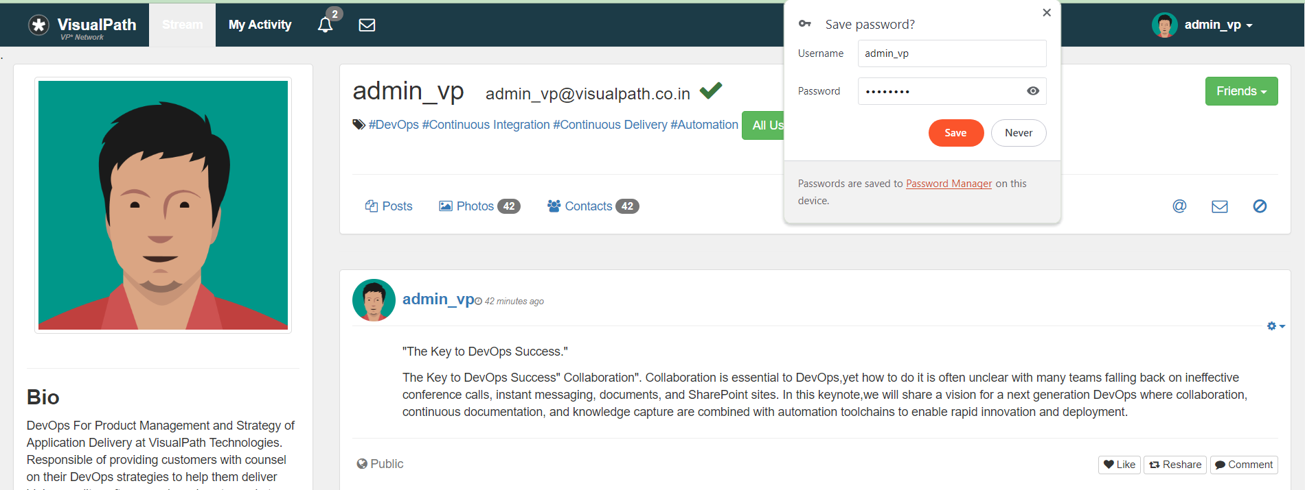

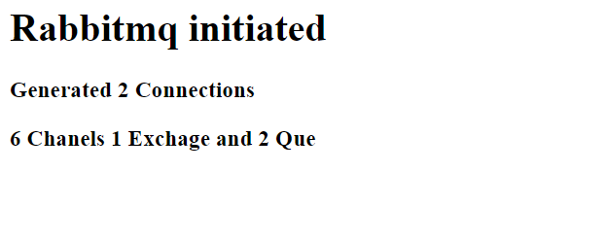

Pushing image to docker repository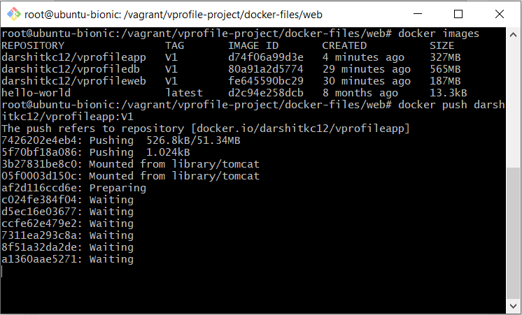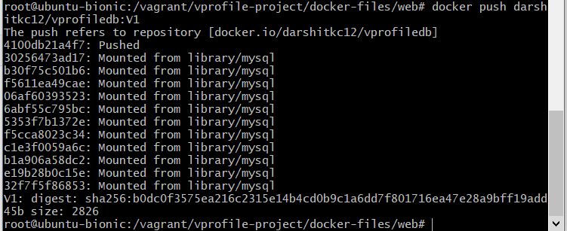

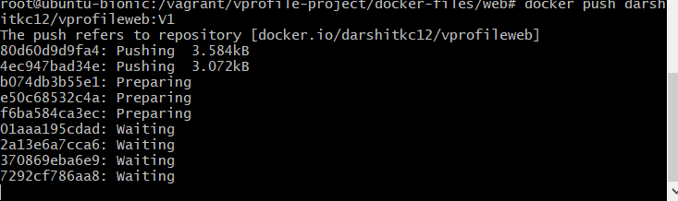

Error

Error due database configuration being wrong

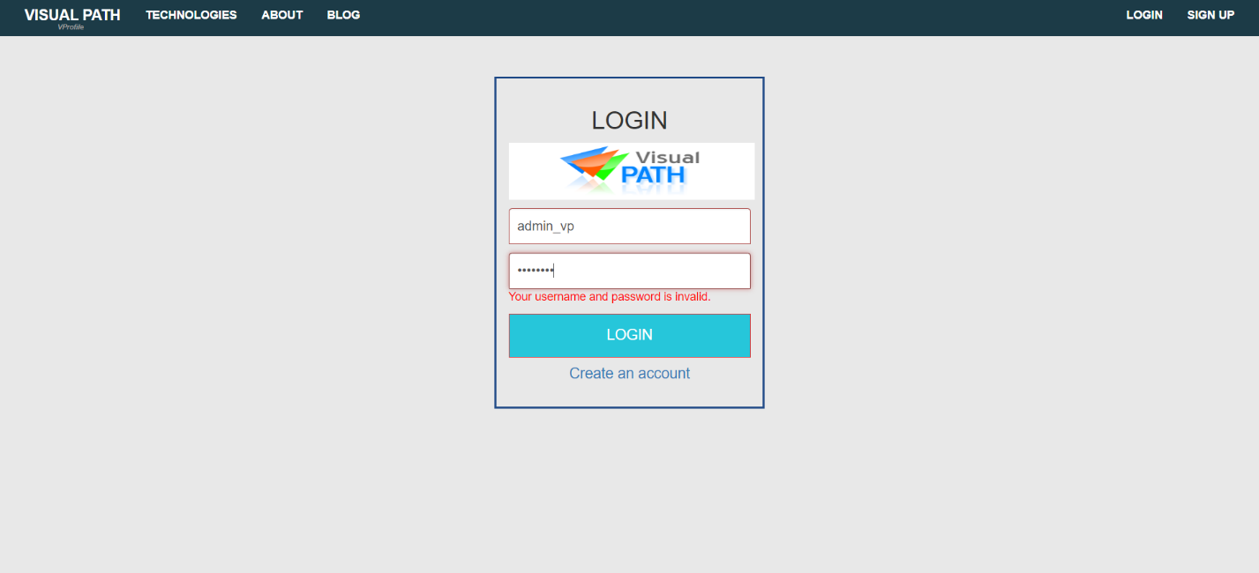

Wrong docker image name

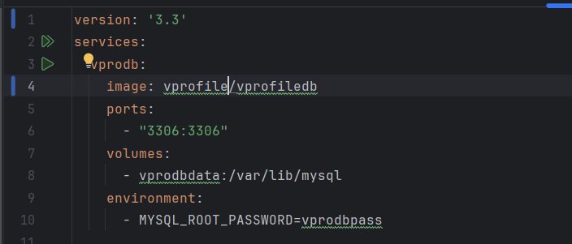

Study Material

The project java file is taken from these git repo

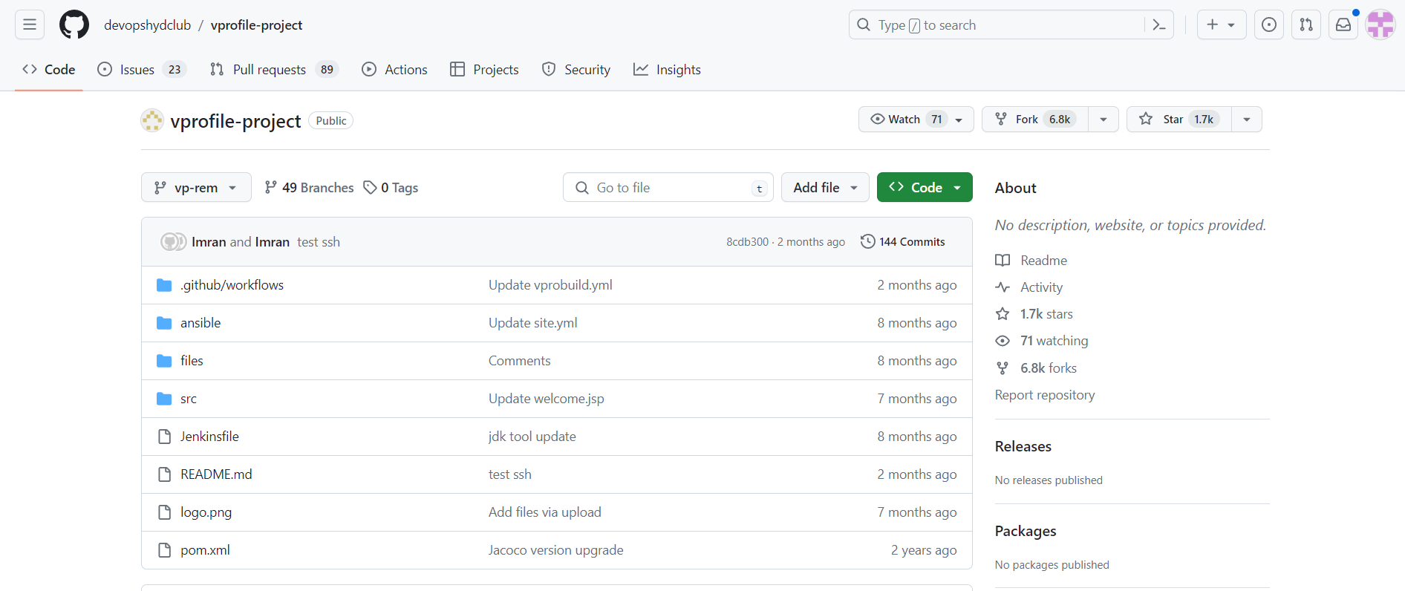

Learning about docker

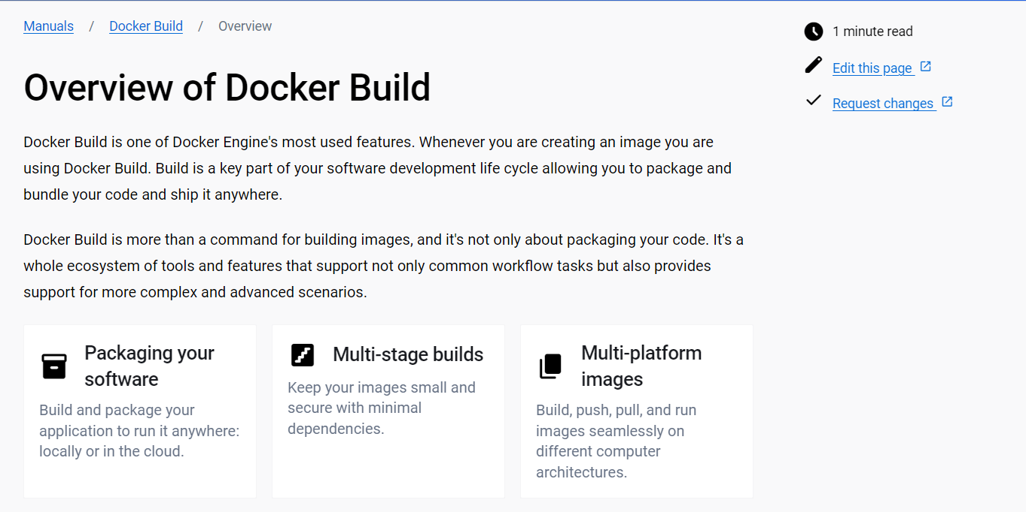

Learning about installation about docker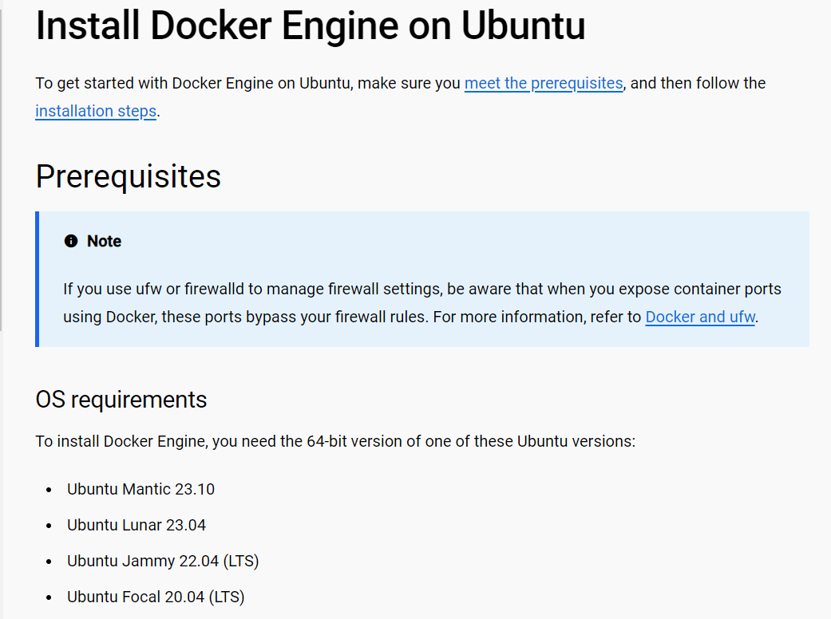

Learning about docker compose

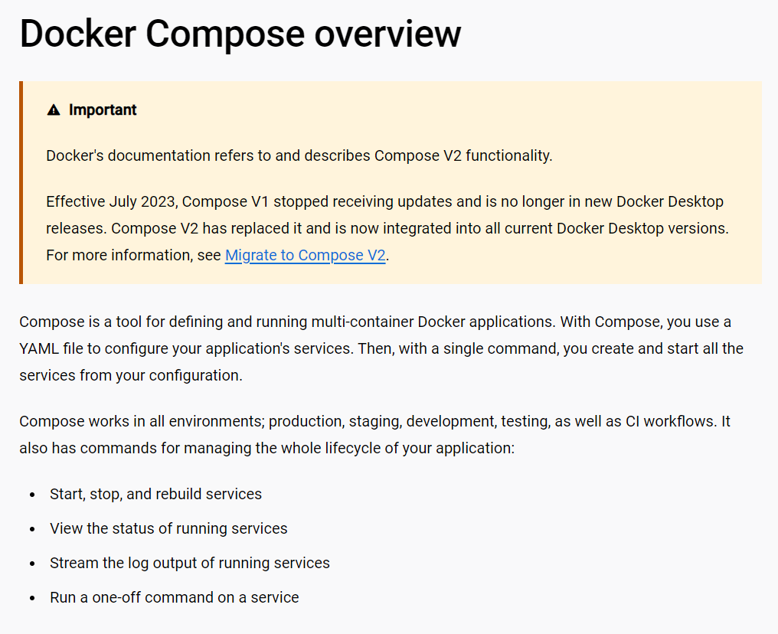

Learning about key and feature about docker compose

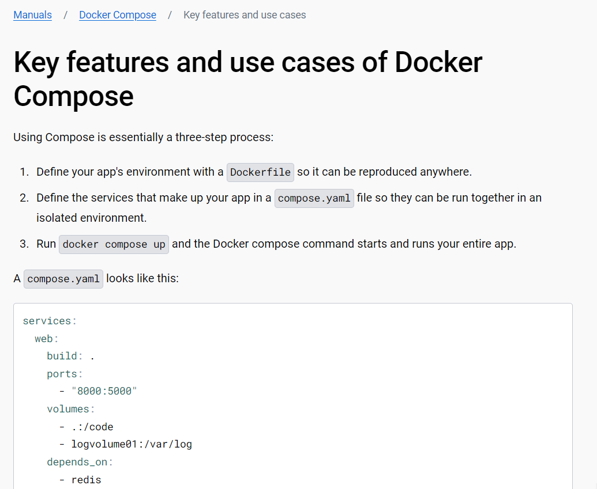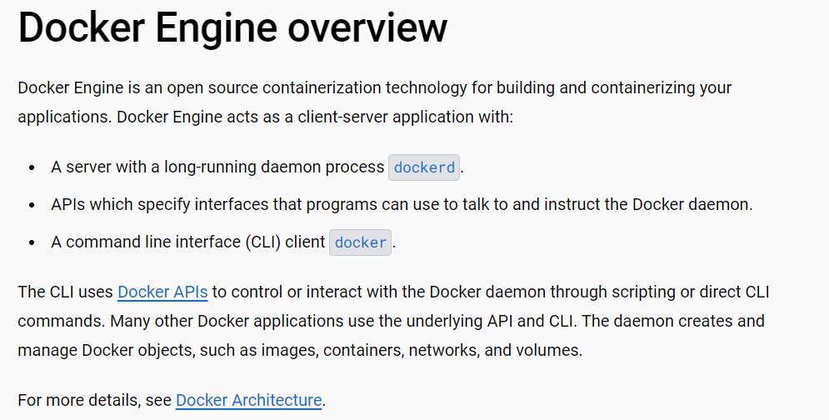

Installing docker compose using repository

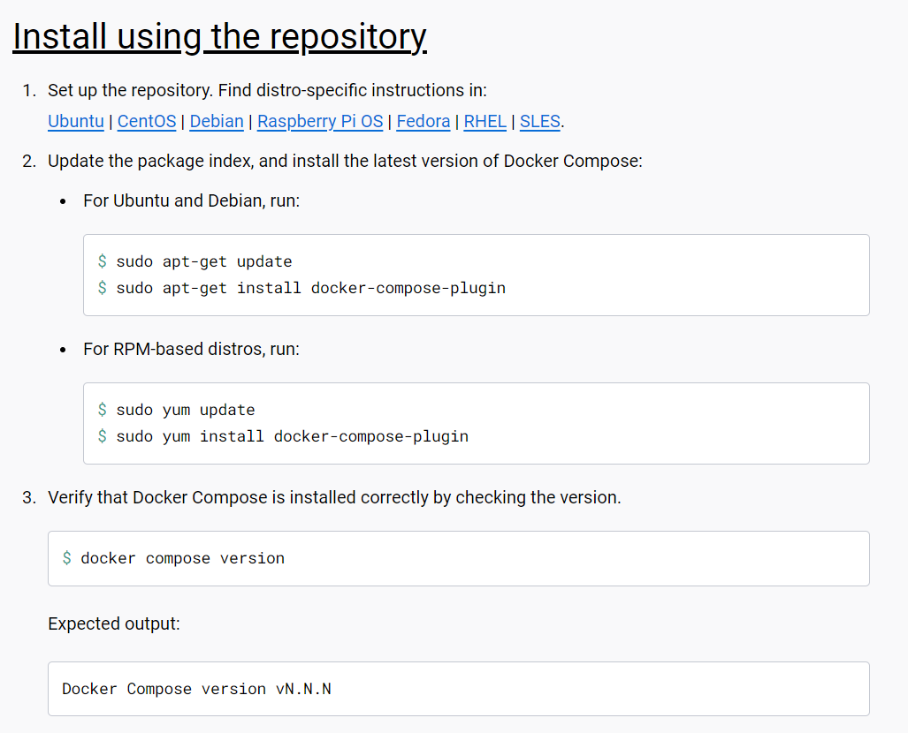

The following project was completed using study material as well as video